**COMP4910 Senior Design Project 1, Fall 2018**

**Advisor: Mehmet Ufuk Çağlayan**

**AGATE: A Web Based Business System**

**Requirements Specifications Document**

**28.12.2018**

**Revision 2.0**

**By: Mehmet Uzunkavakaltındayataruyuroğlu**

**Student ID Number: 123456789**

# Revision History

|  |  |  |
| --- | --- | --- |
| **Revision** | **Date** | **Explanation** |
| 1.0 | 26.11.2018 | Initial requirements |
| 2.0 | 28.12.2018 | Requirements Model |

# Contents

Revision History 2

Contents 3

1. Introduction 4

2. Requirements List 6

3. Actors and Use Cases 7

4. Glossary 13

5. Initial Architecture 14

6. Activities of Requirements Modelling 15

7. References 16

# 1. Introduction

**Notes by MUC about this section:**

Introduction text below is just a copy of “Introduction to Agate” Section in RSD Rev 1.0, since this is just an example. In a real life situation, this section will be an improved and perhaps expanded version of “Introduction to Agate” Section in RSD Rev 1.0

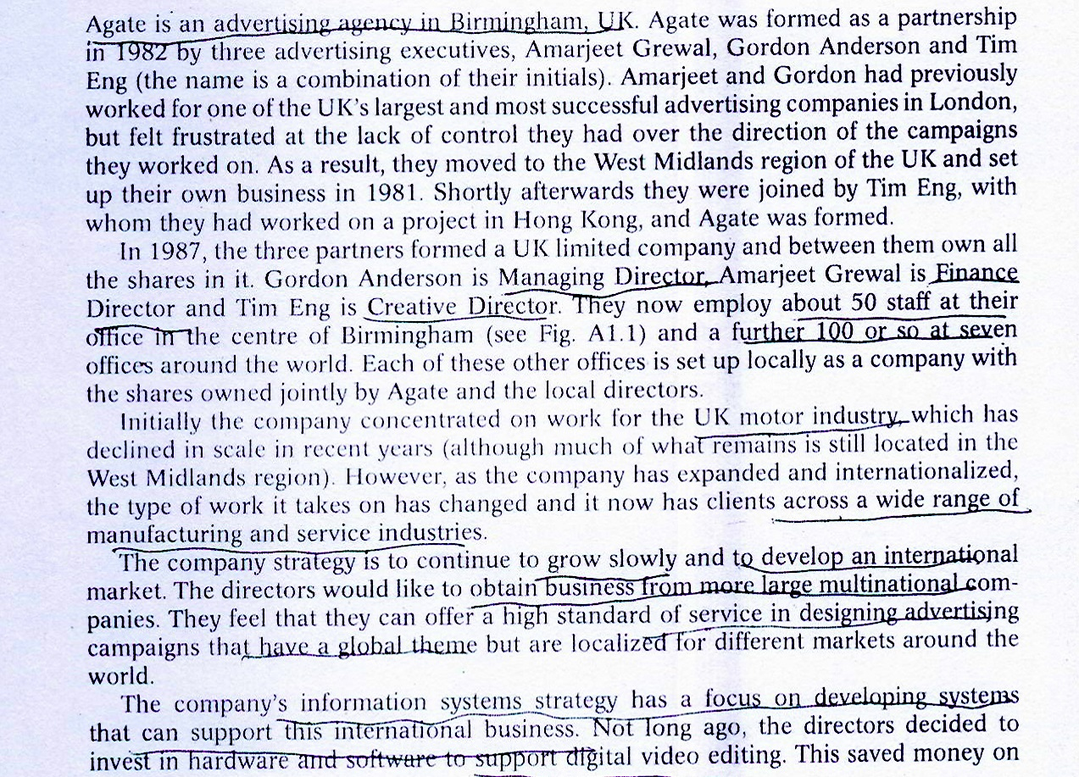

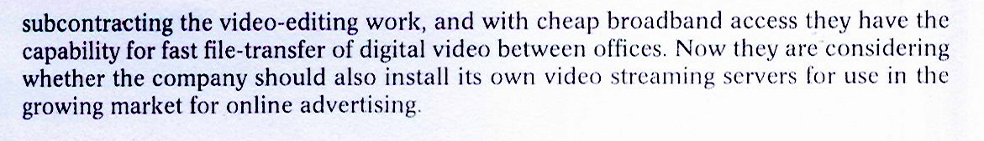

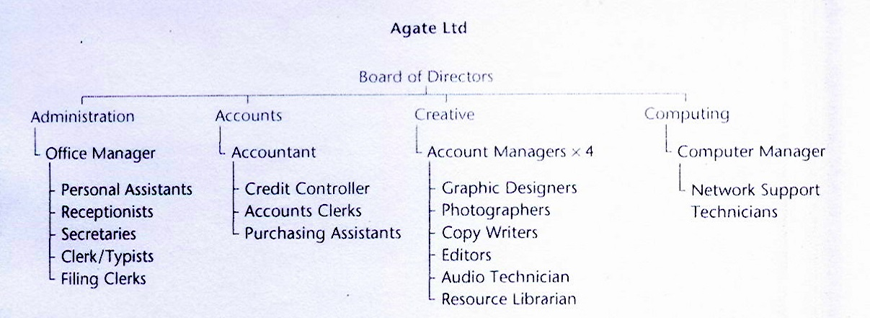

Fig. 1.1. Staff at Agate LTD. UK Office

**More notes about this section from Reference (1) are below:**

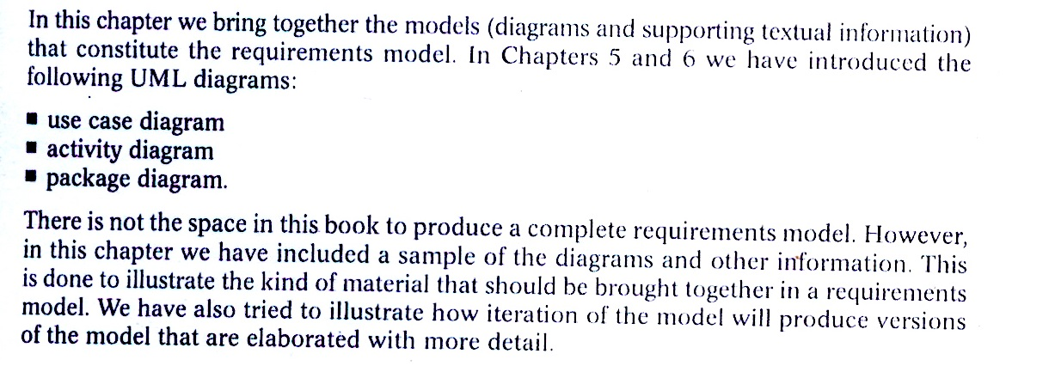

**End of notes from Reference (1)**

# 2. Requirements List

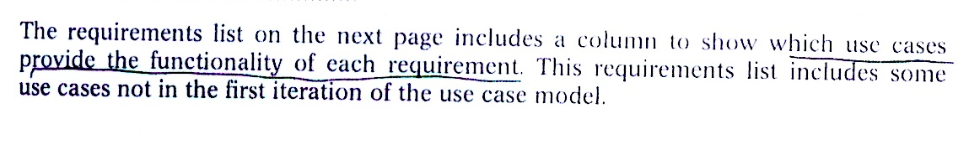

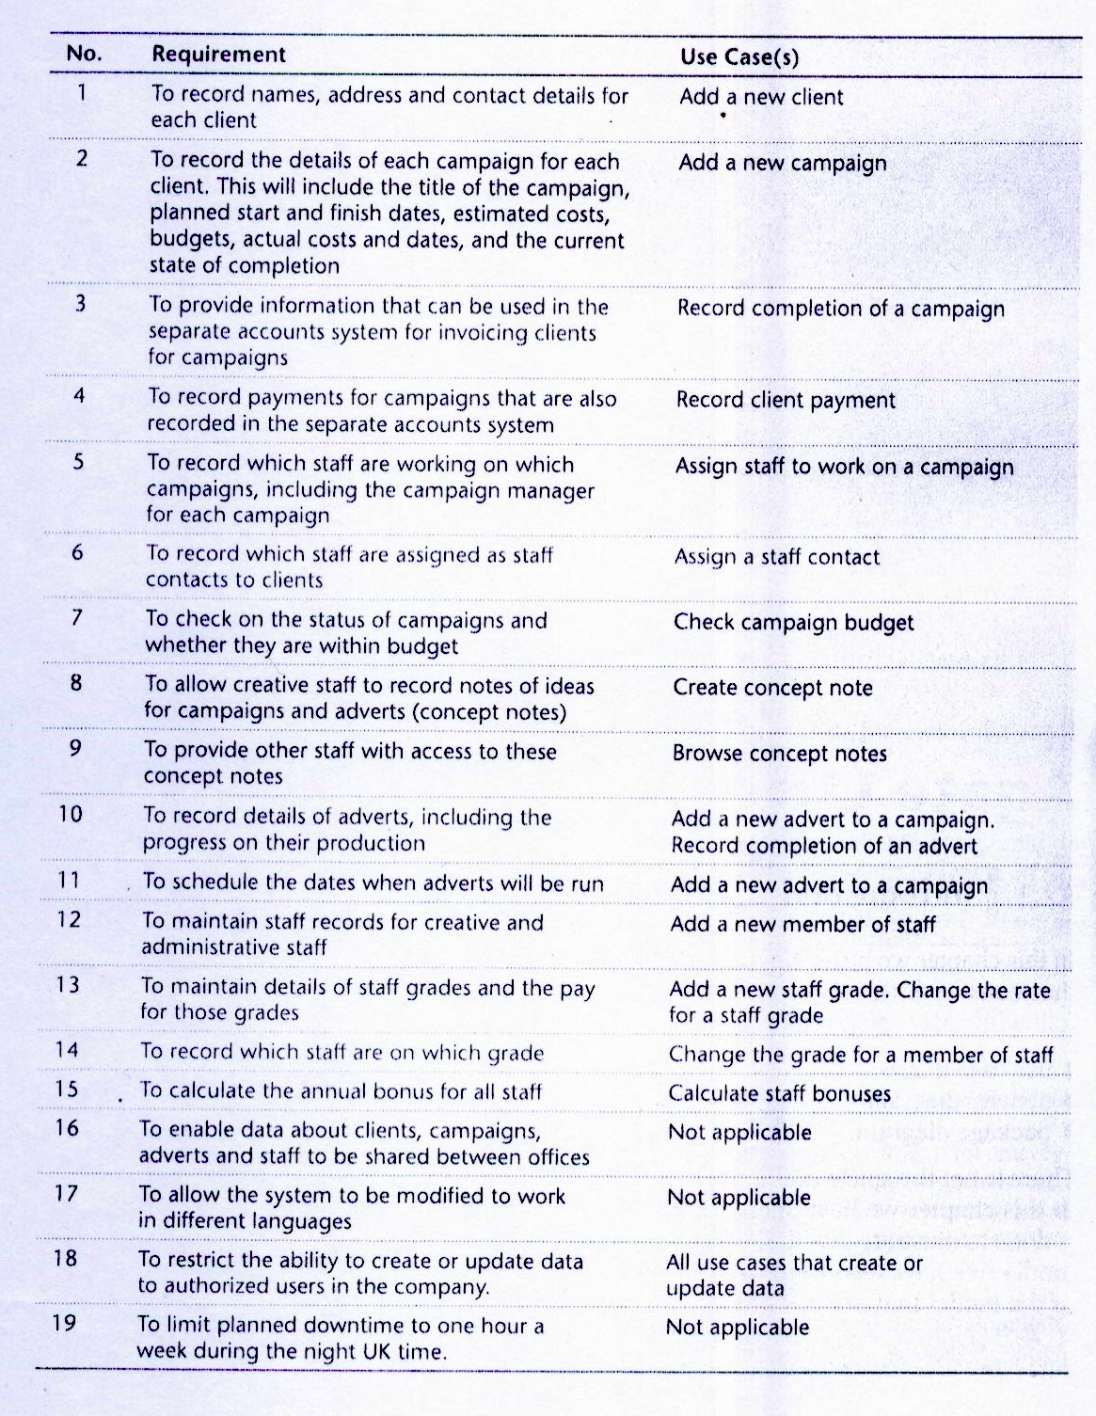

# 3. Actors and Use Cases

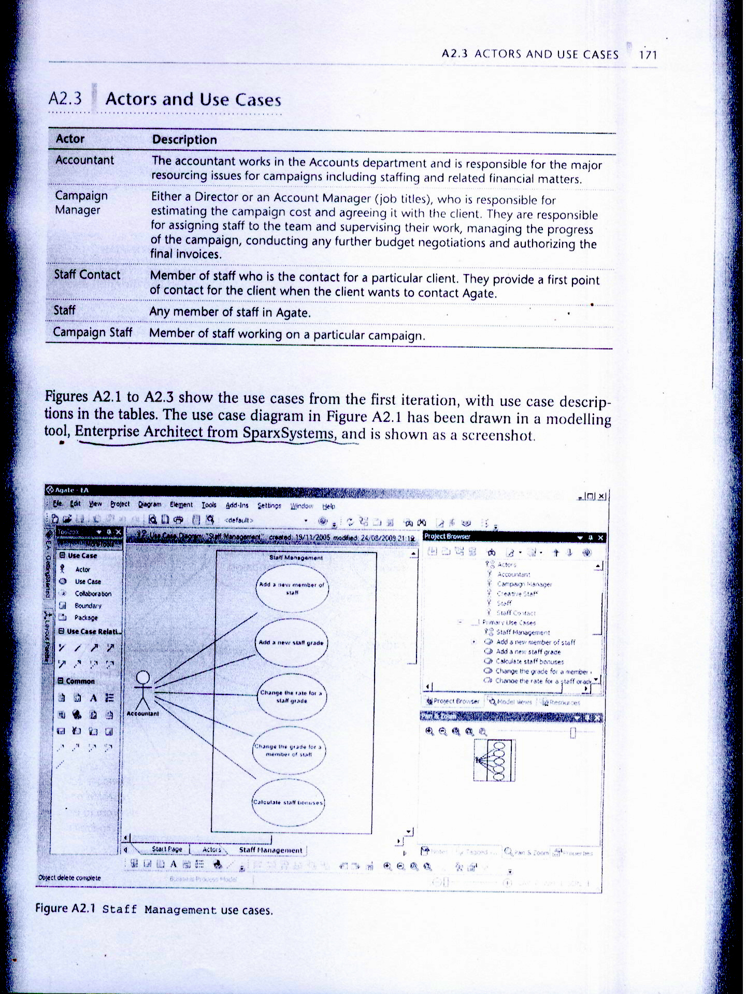

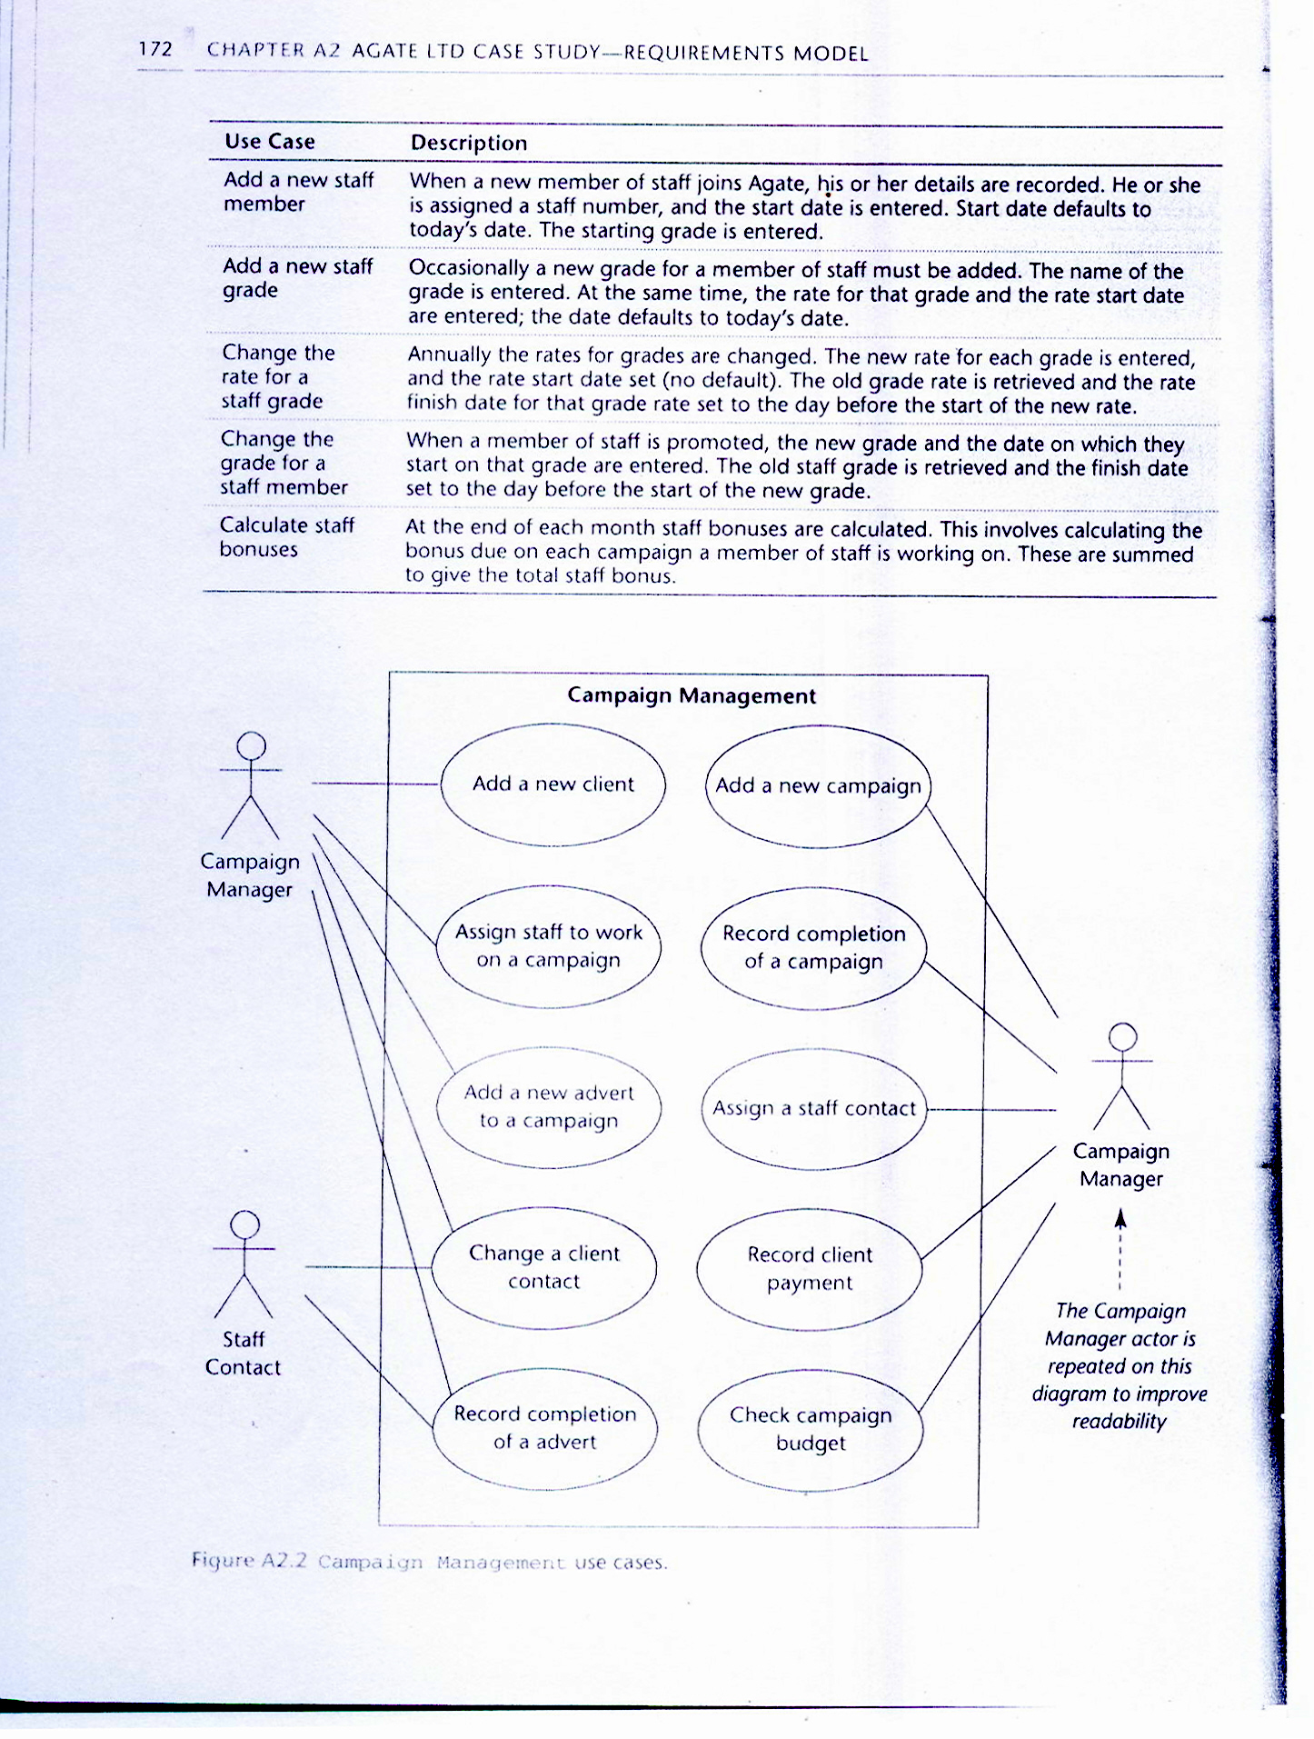

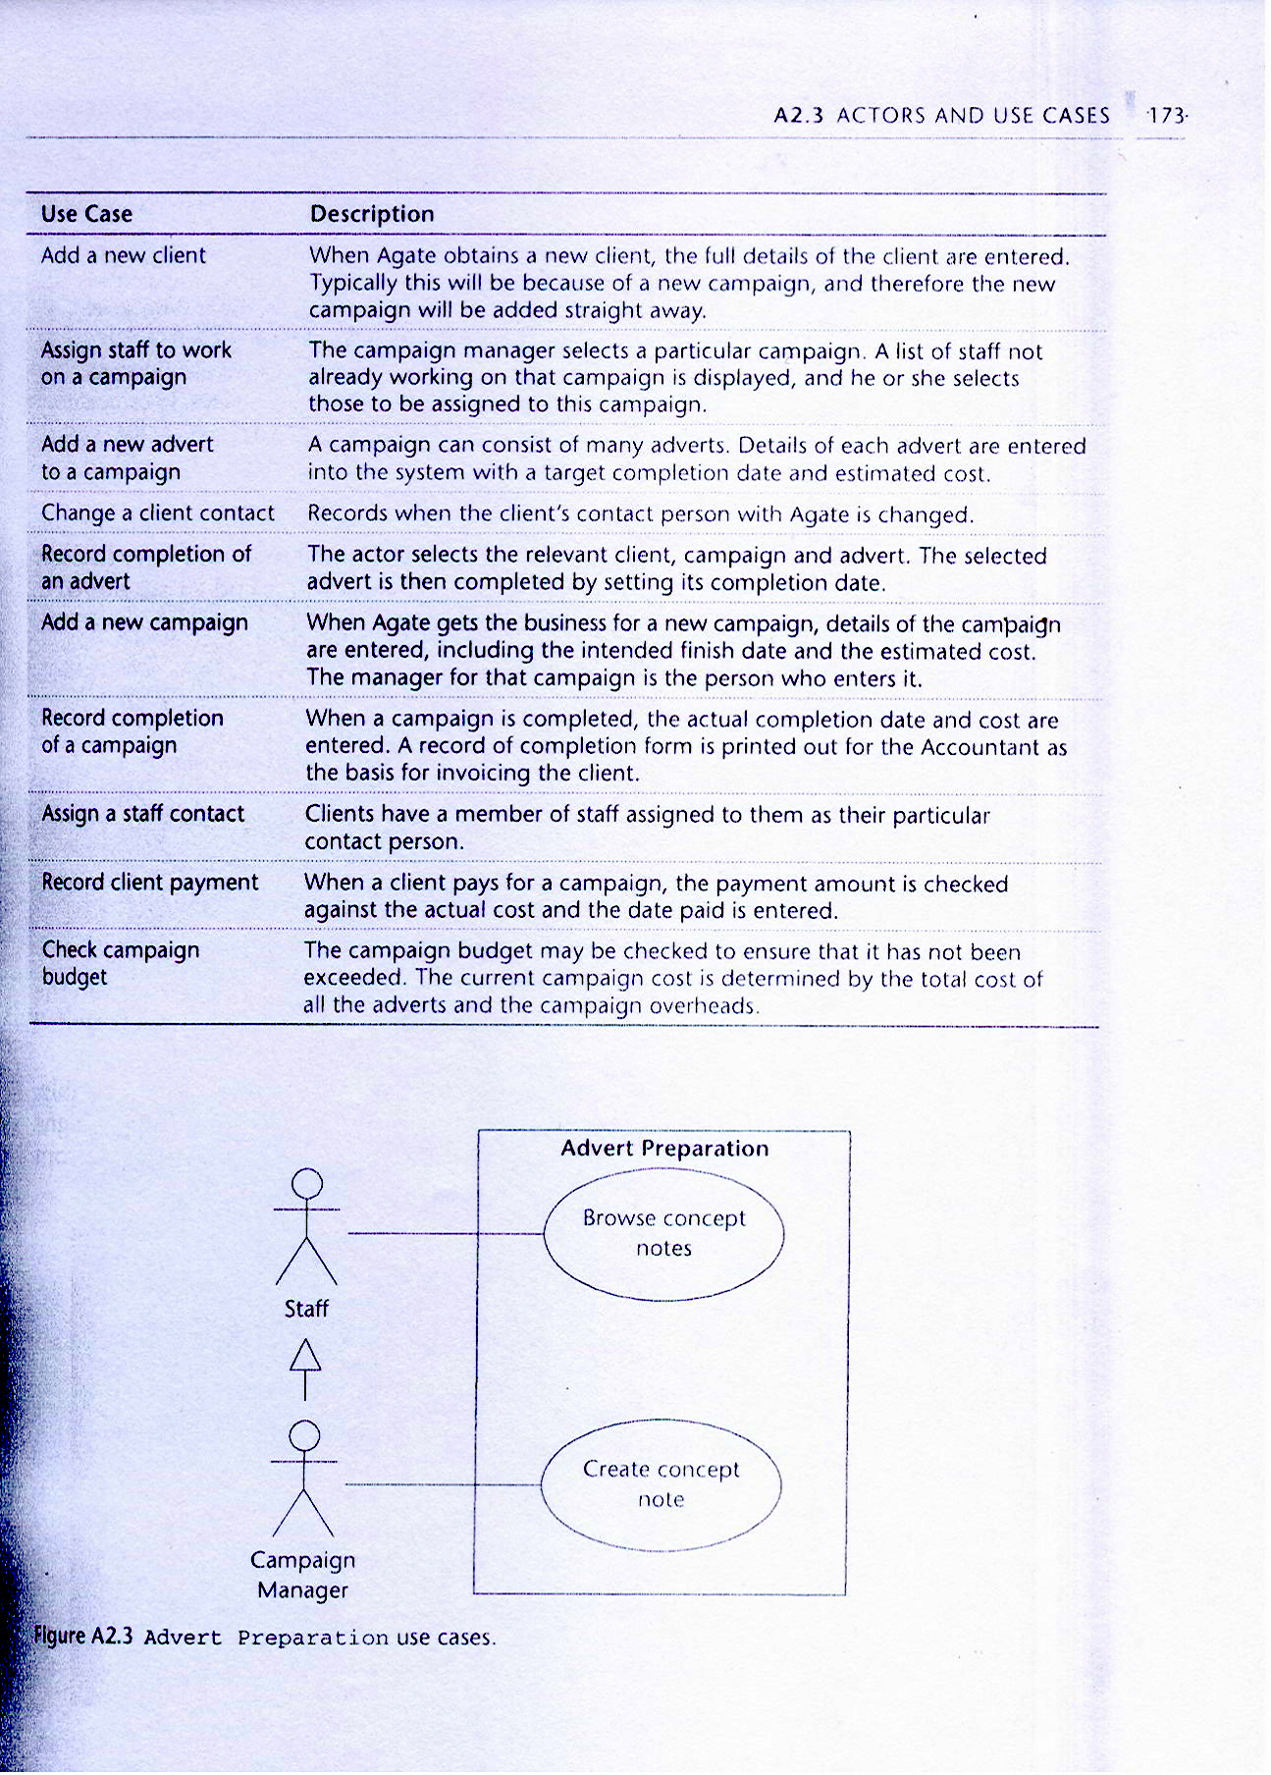

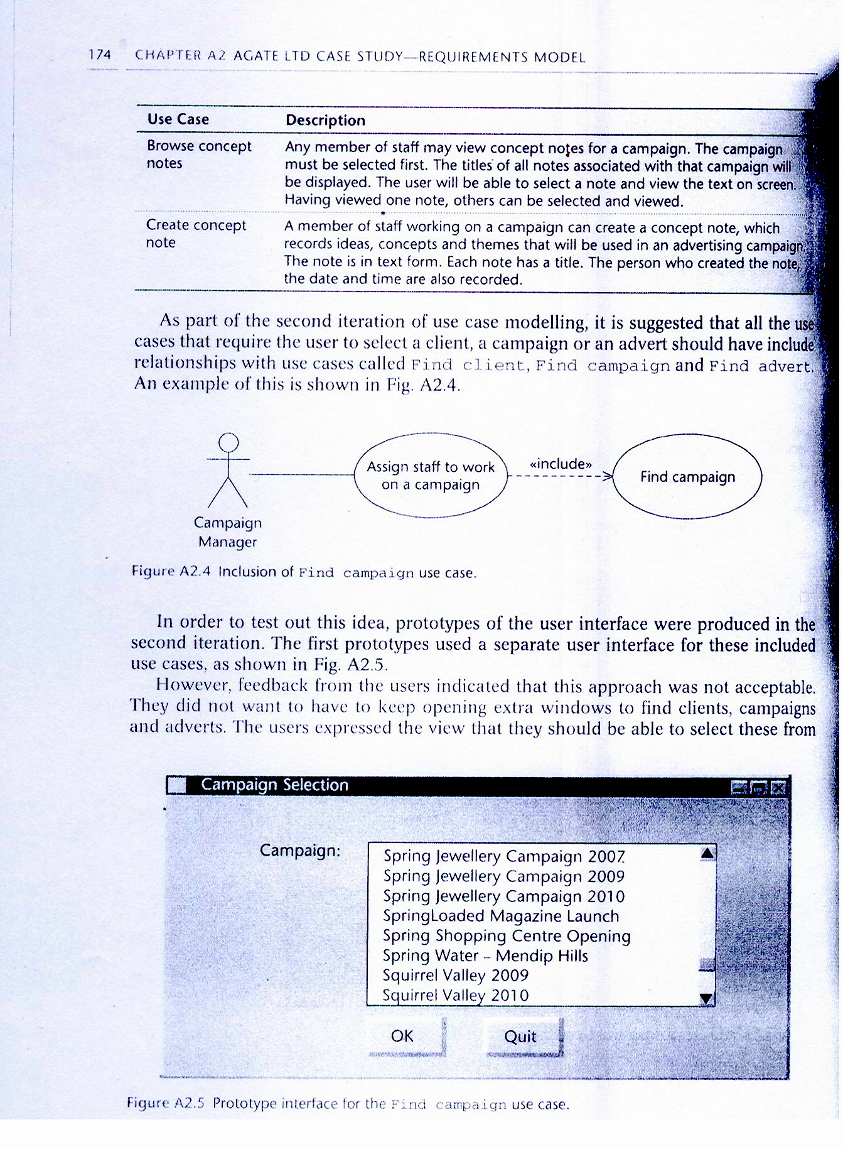

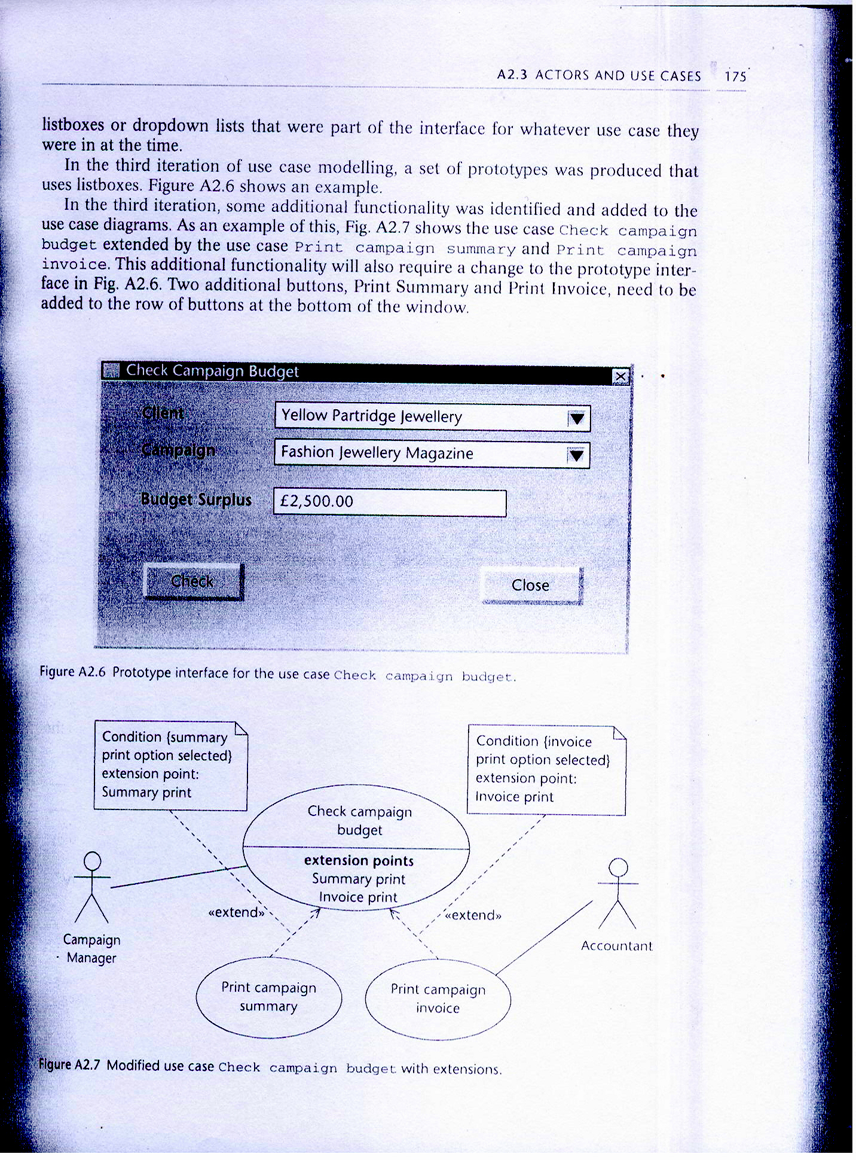

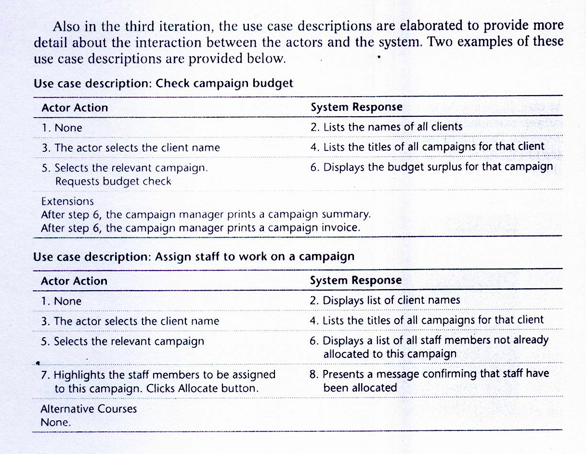

# 4. Glossary

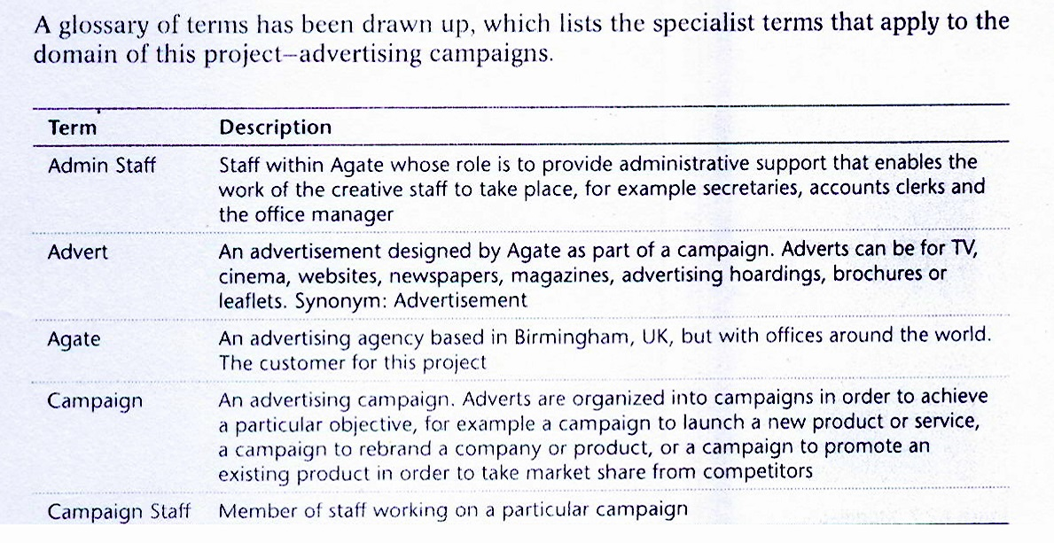

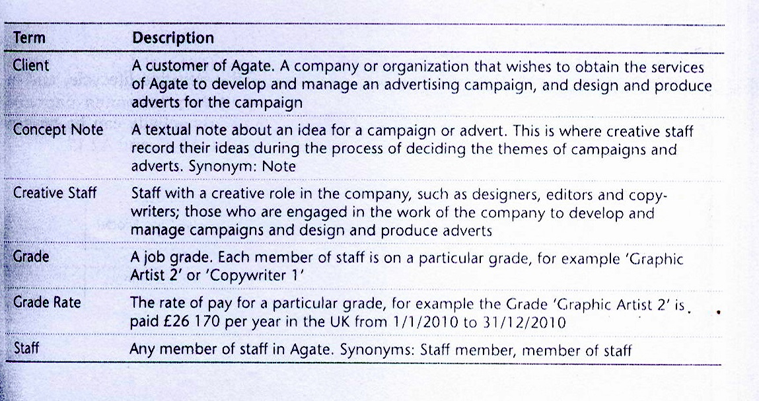

# 5. Initial Architecture

**Notes by MUC about this section:**

This section is not actually necessary in our project work, it has been placed here for completeness with respect to **Reference (1).**

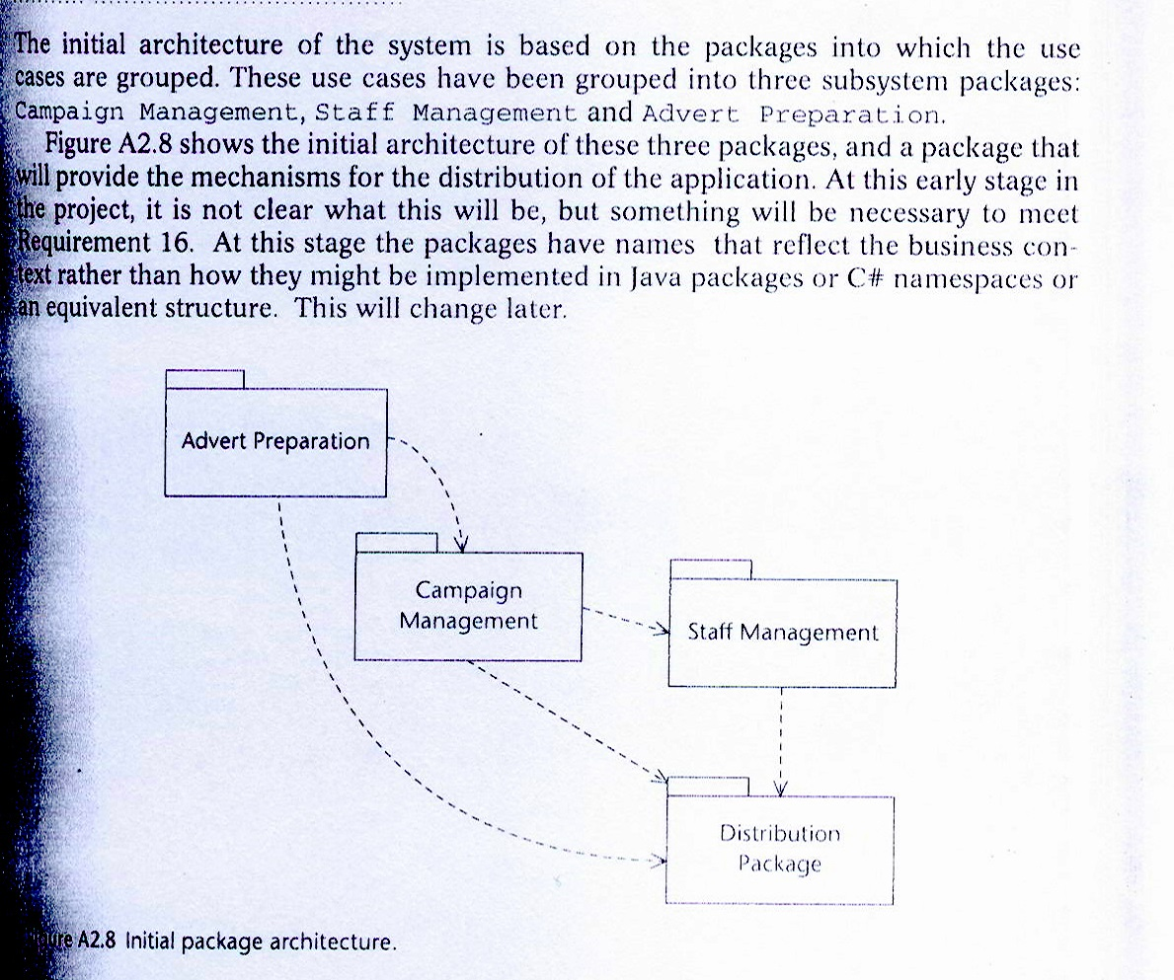

# 6. Activities of Requirements Modelling

**Notes by MUC about this section:**

This section is not actually necessary in our project work, it has been placed here for completeness with respect to **Reference (1).**

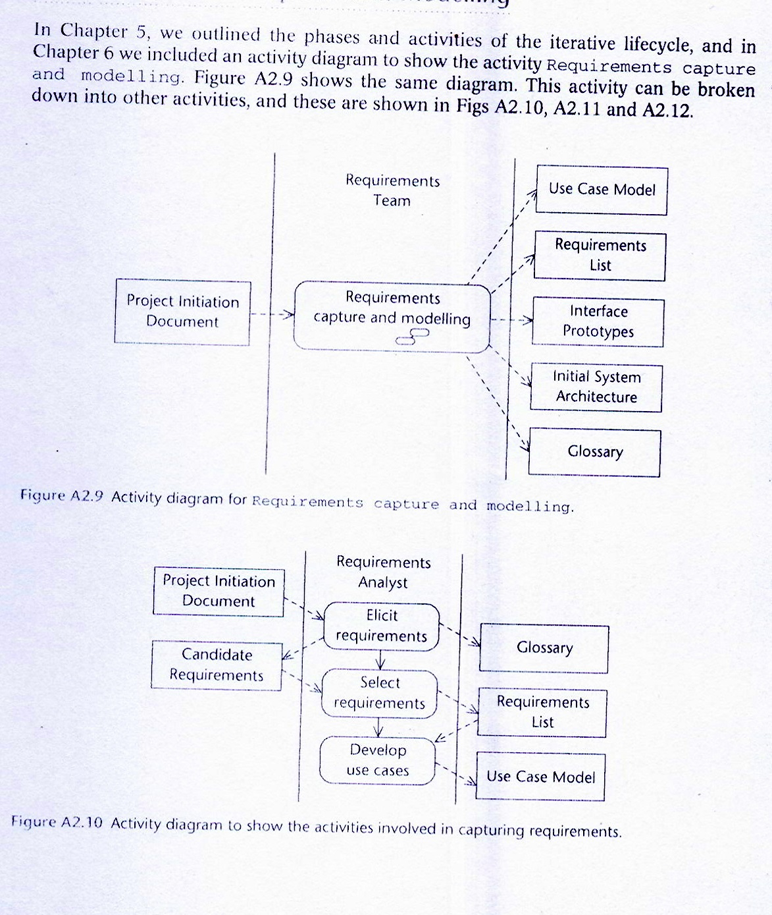

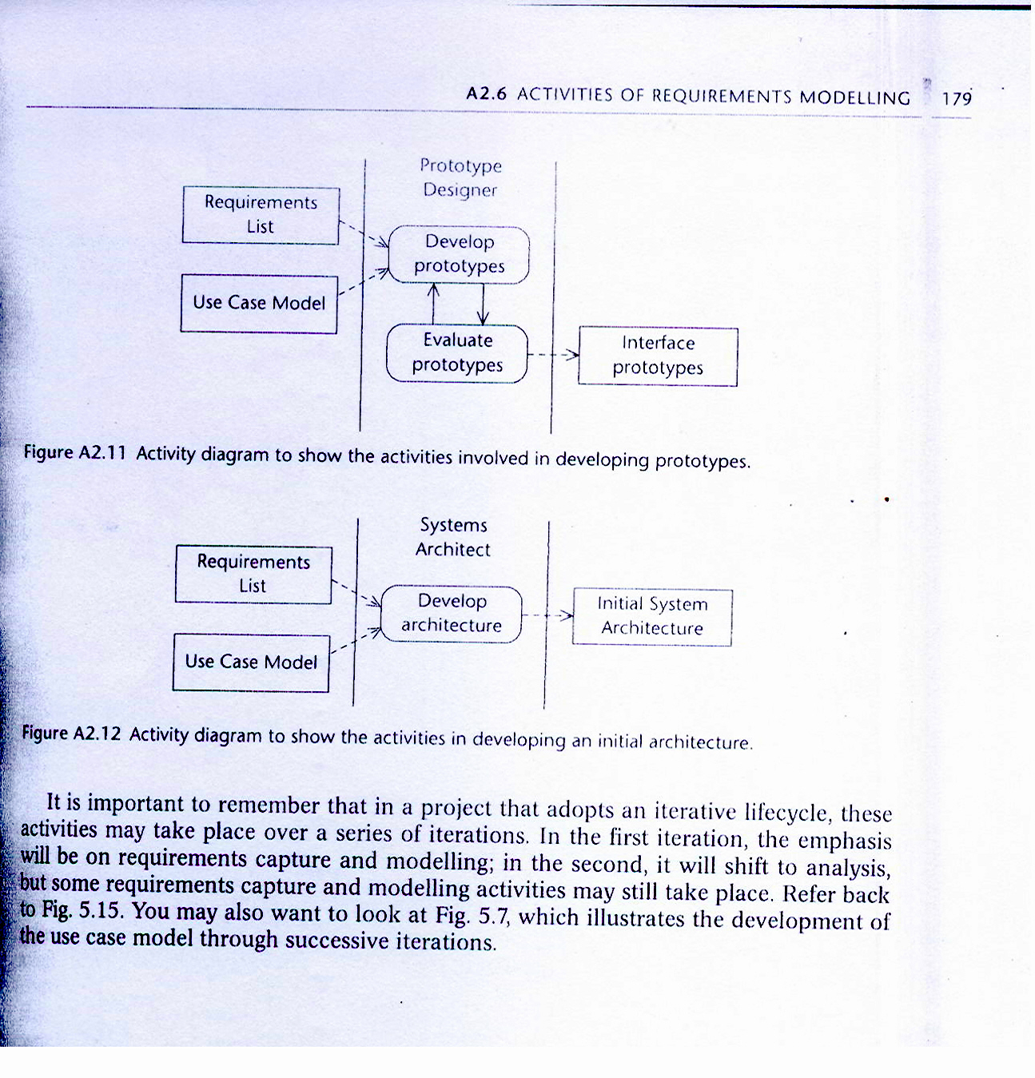

# 7. References

1. For Agate Case Study, see: Bennett, McRobb, Farmer, Object Oriented Systems Analysis and Design Using UML, McGraw-Hill, 2010, 4th Edition.
2. R. S. Pressman, Software Engineering: A Practitioner’s Approach, McGraw Hill, 7th Edition, 2010.
3. Document About Agate Company Policies, A-123, 2015.
4. Etc.